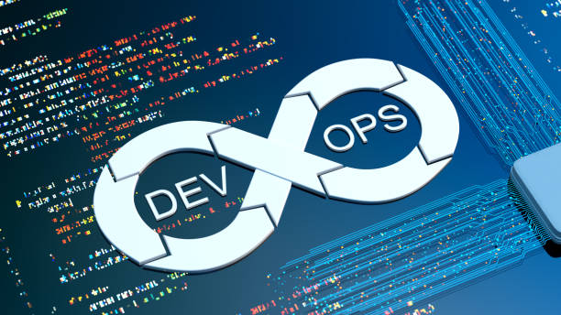SE489 DevOps Engineering

Lab 4

# Lab 4: Continuous Integration and Continuous Release

## Preambles: Jenkins is a tool to achieve continuous integrations and continuous delivery

Just google for jenkins download, [www.jenkins.io](http://www.jenkins.io) is the official website for the jenkins. Click the first link to download jenkins.

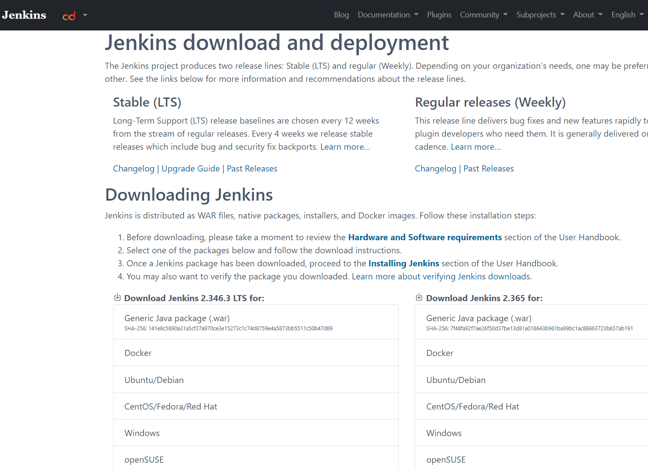

Go for LTS (Long Term Support) version, Out of several options listed select windows, Automatic download of installer file will start. Once done, you can check it’s a msi installer.

There are some software requirements also for jenkins, website puts them like this

**Software Requirement:**

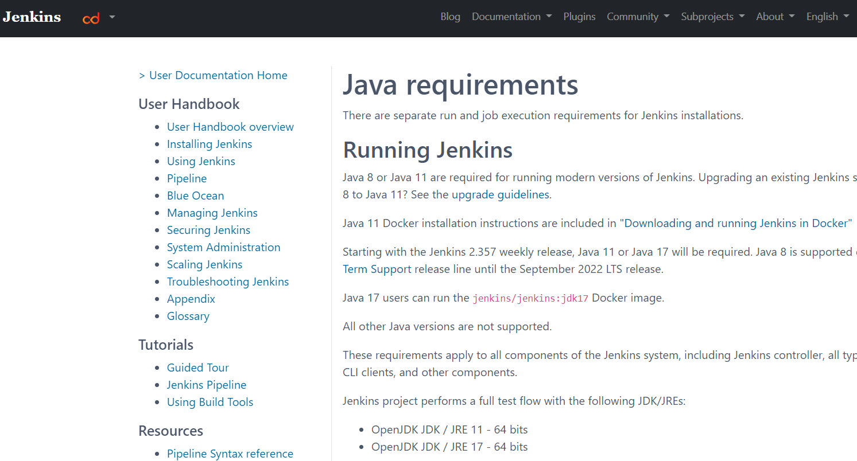

Let’s check java’s version first, open command window and run the following command to confirm the version of the java

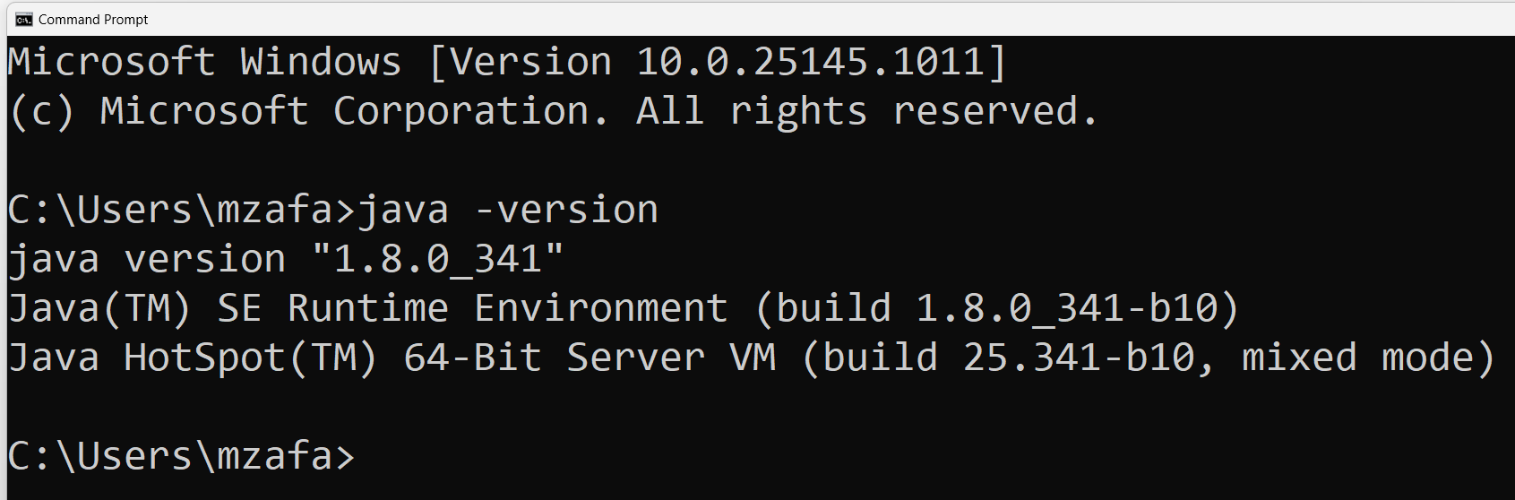

If it is 8,11 or 17, it will work fine.

**Hardware Requirements:** As mentioned at the jenkins website, followings are requirements

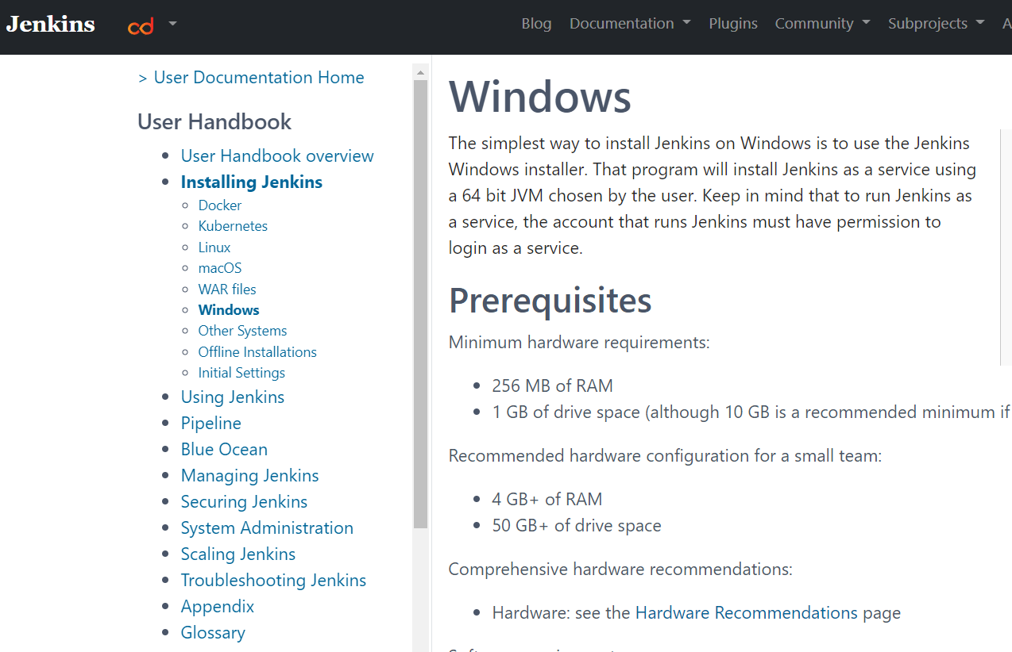

If these requirements are fulfilled, then proceed for the installation of the jenkins, browse to the download location of the jenkin setup file, double click on it to starting the installation process

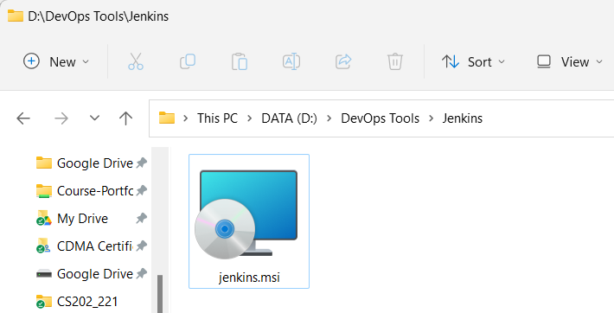

Following screen will appear

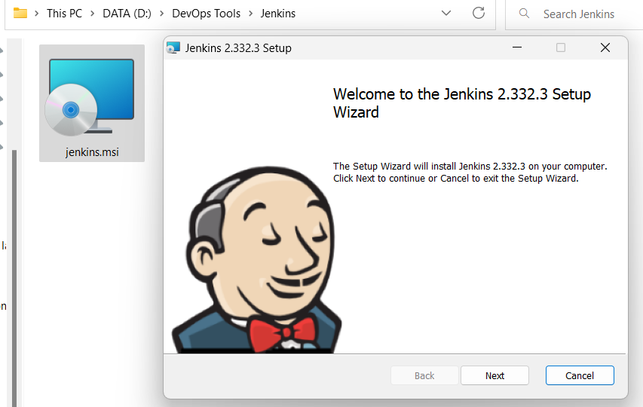

To proceed with the installation process, click on next

Accept the default location, if you don’t want to change it

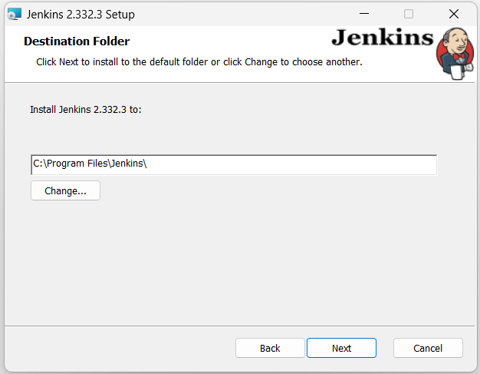

To avoid other overheads, choose first option on the next screen presented.

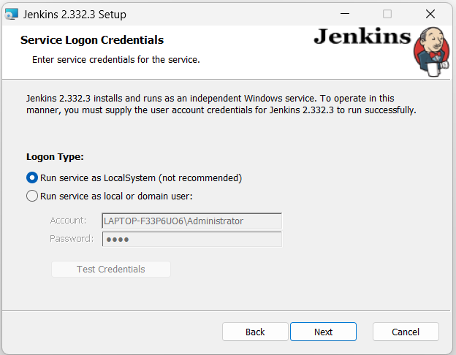

By default, jenkins runs on port 8080, you may test port as well

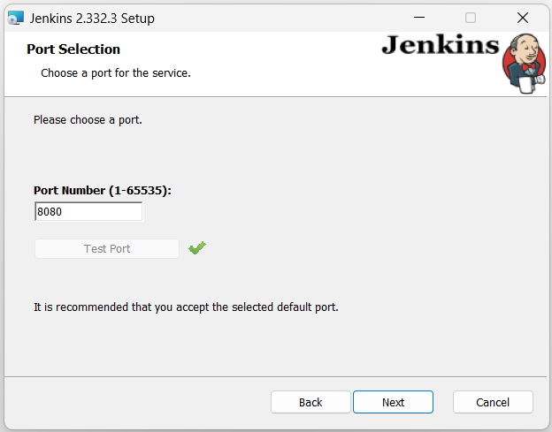

Click next, and let Jenkin select version of java for it, although, jenkins recommends, Java version 11, for sake of compatibility with other tools installed on laptop, I will continue with version 8.

Simply click Ok, if you receive this

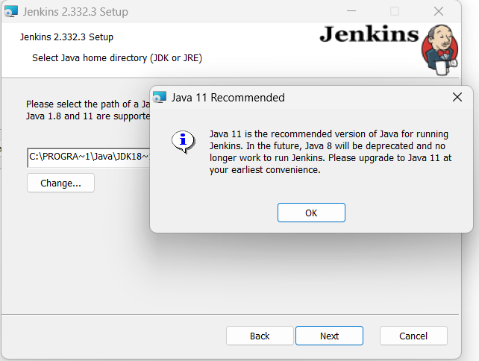

Leave the firewall services off, and select next to the next screen

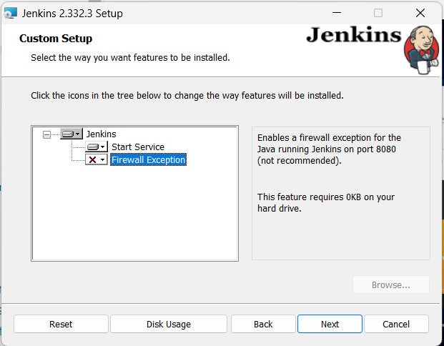

Click on install, to complete the installation process.

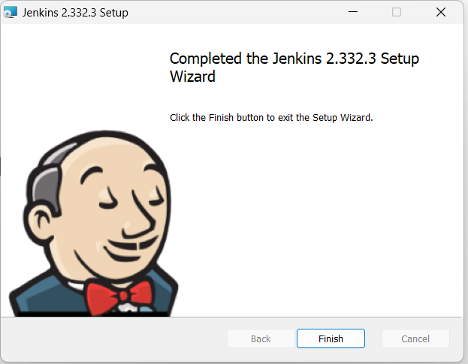

Now Jenkins, has been installed at your computer, let’s unlock and configure it a bit.

**Running, Unlocking and Using Jenkins**

As Jenkins runs at local port 8080, enter url <http://localhost:8080> at your browser

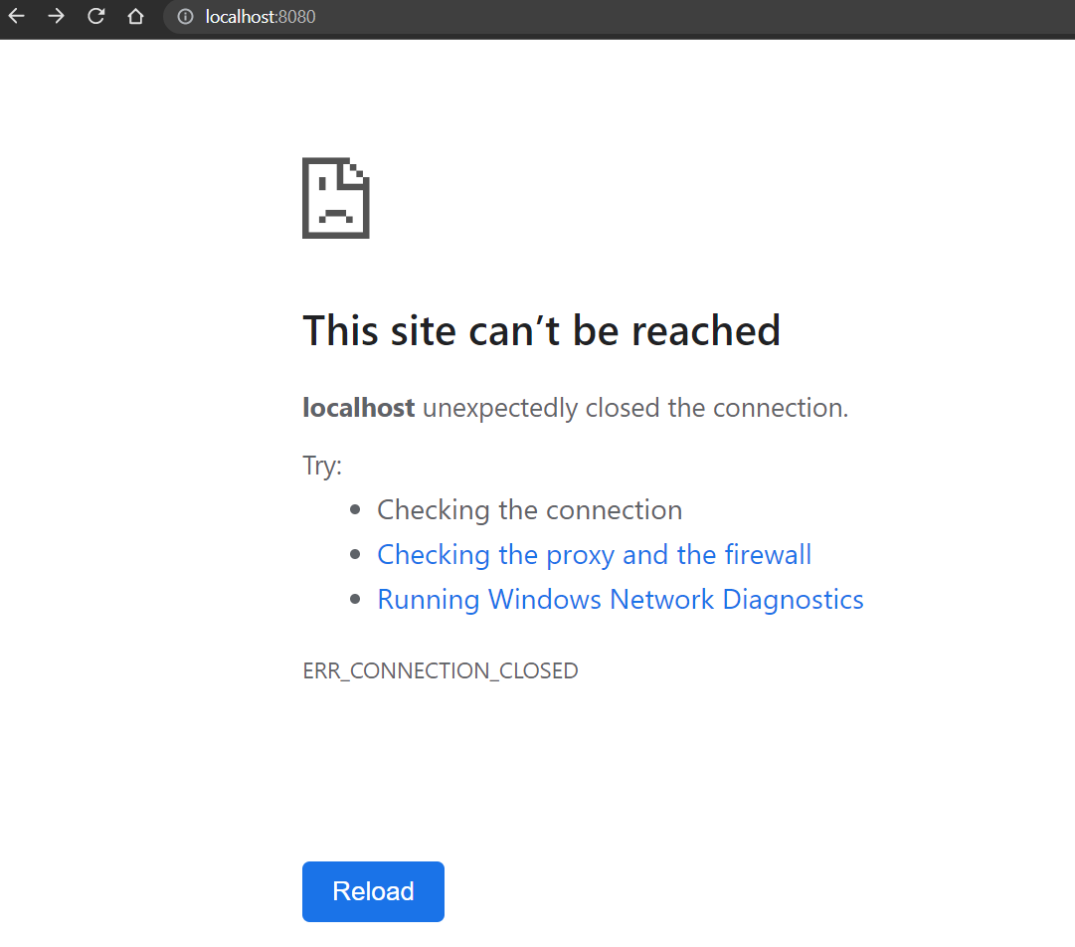

Because for security reasons, we didn’t add, firewall exception while installing jenkin, this window will appear, just click on the ***Checking the proxy and the firewall*** options and you will be taken to below window

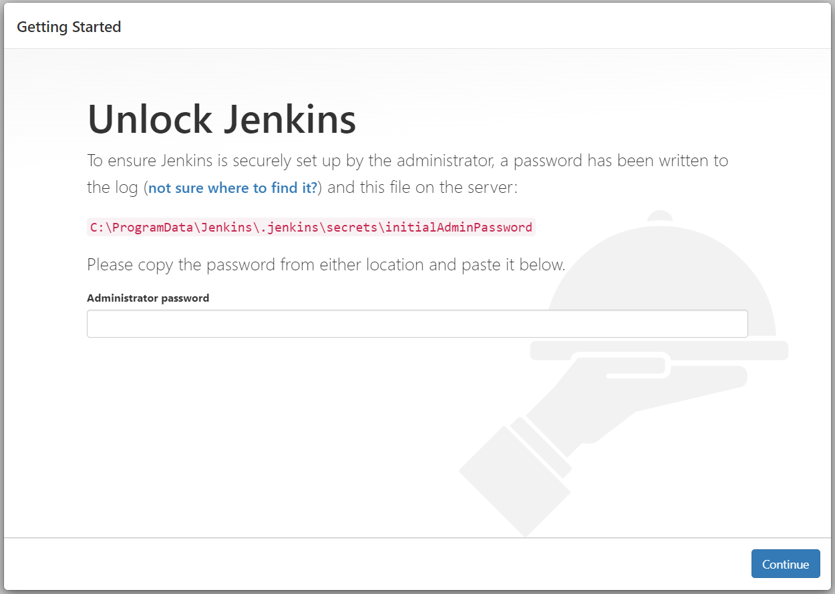

Let’s get the sought password from the given location, and paste it. Copy and paste, given location at windows explorer’s address bar, select notepad at the subsequent window, to open password file.

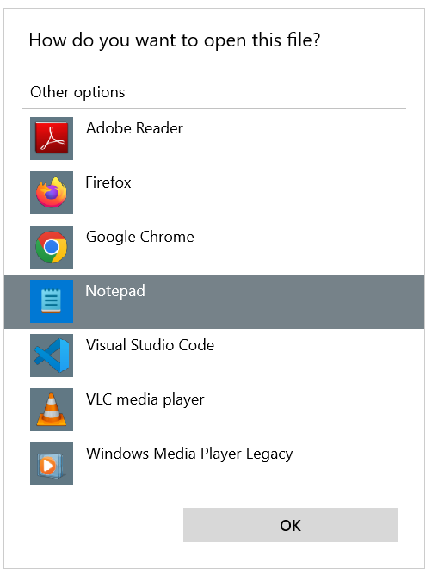

Once in the file, copy the password

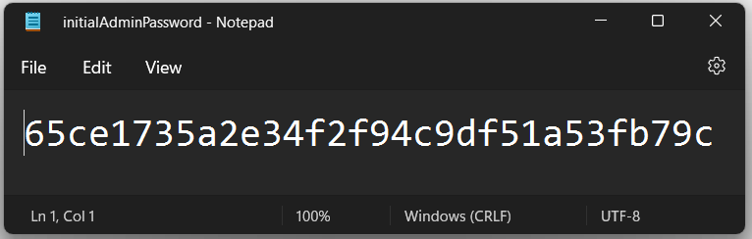

Paste the password and click on continue

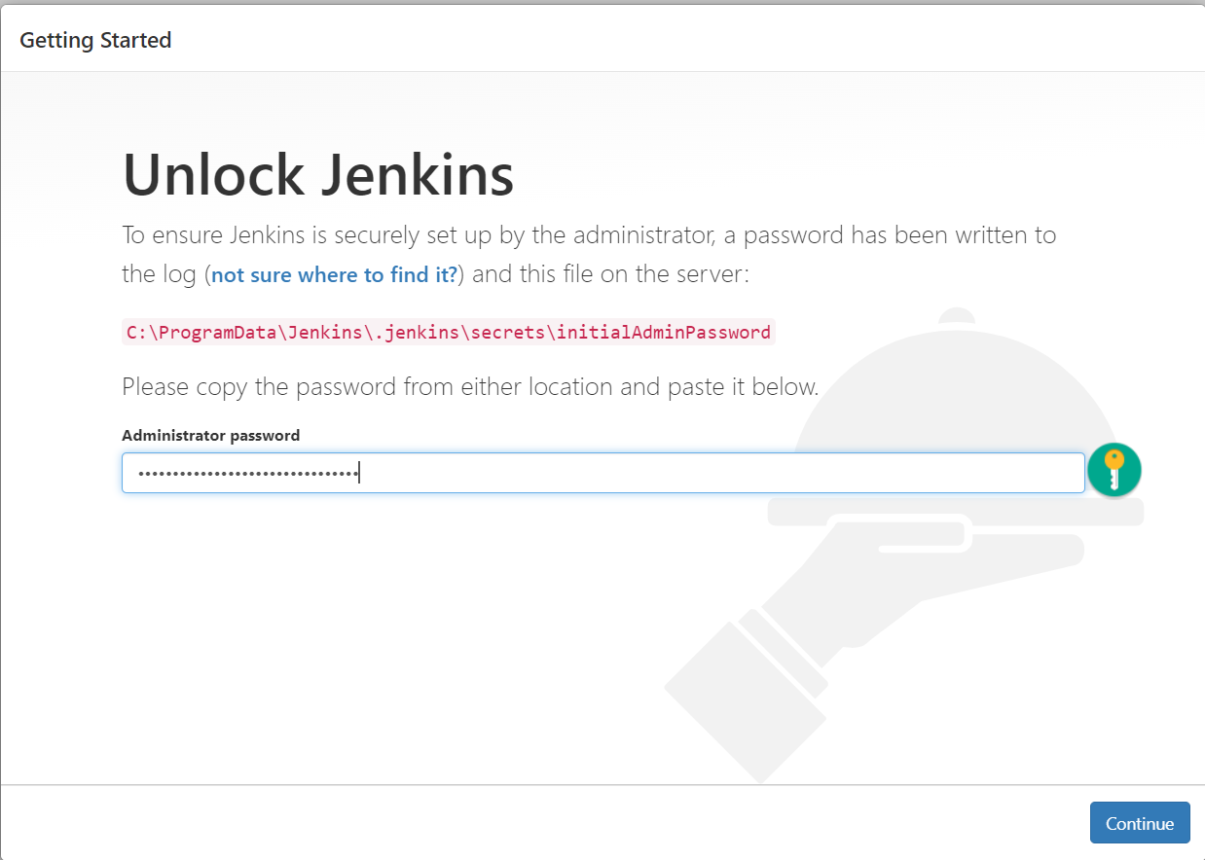

At the subsequent screen it asks for plugins to be installed, select recommended plugins 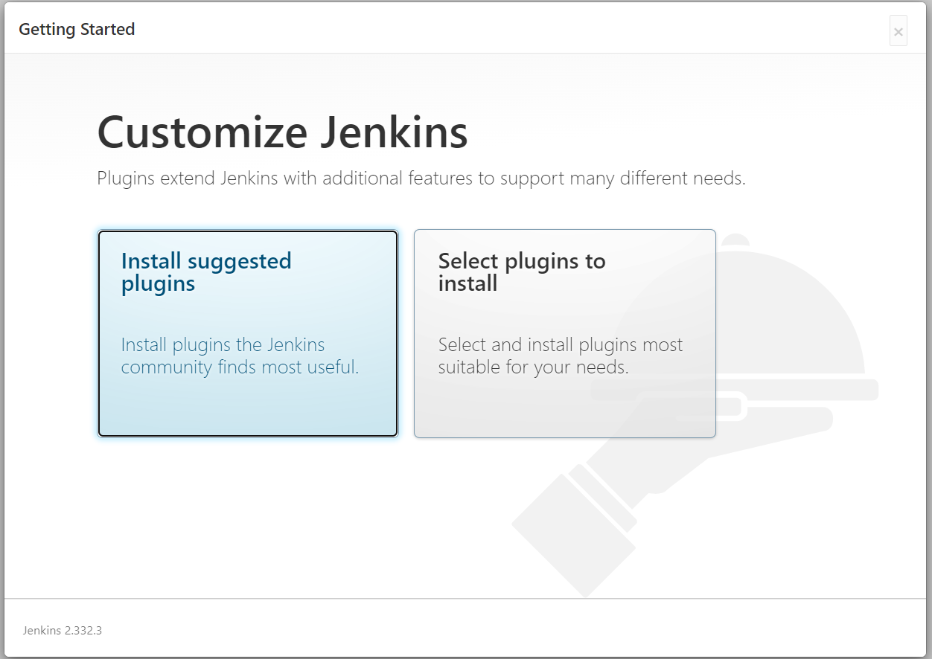

Depending upon network speed, it may take few minutes to install recommended plugins

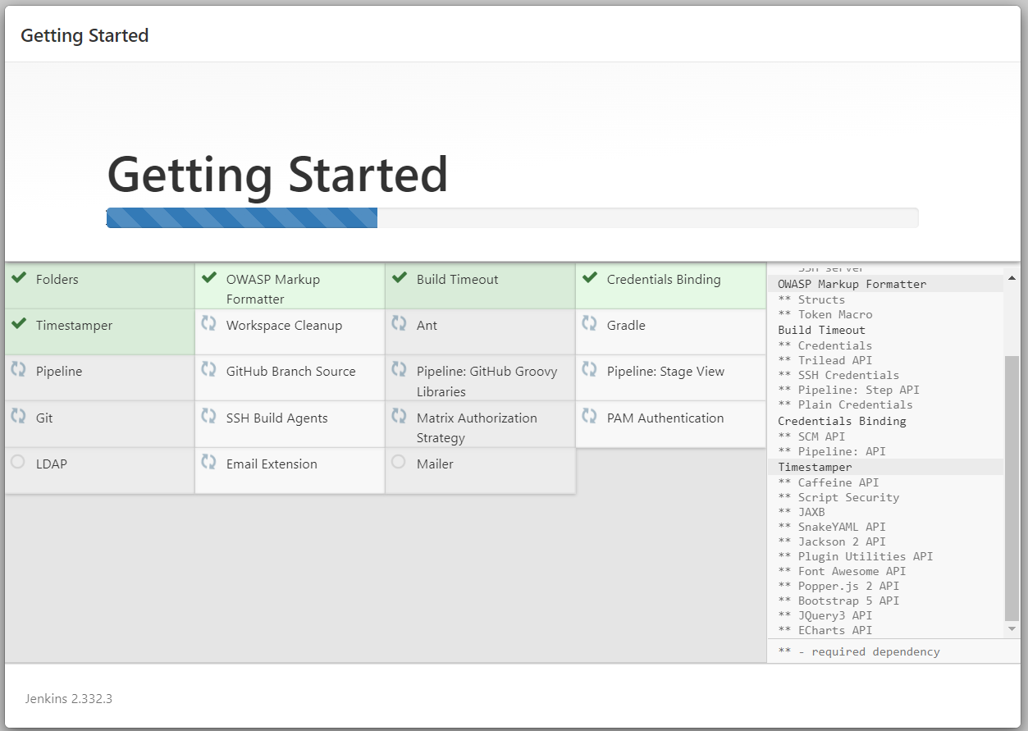

After this jenkins asks for creation of an Administrative user accounts

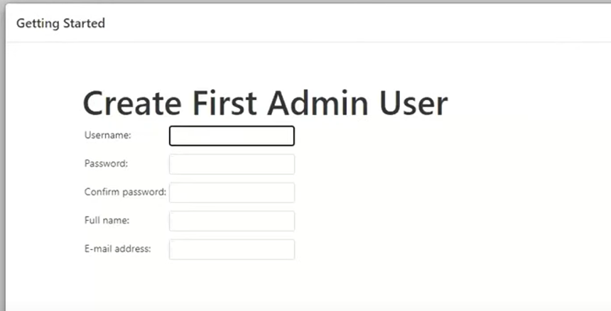

After completion of this step, Jenkins is ready for the use

Click on Start using Jenkins, and following ***Dashboard*** will be presented to you

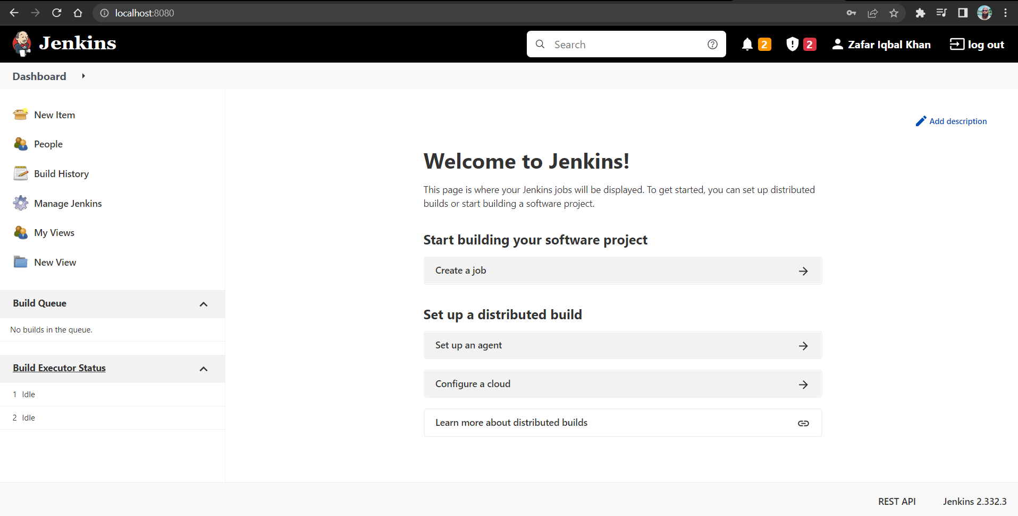

# Creating first job

To create a job, click **New Item**, first option on the left side pane, and provide a suitable name for the first project, select Freestlyle project, and click on Ok

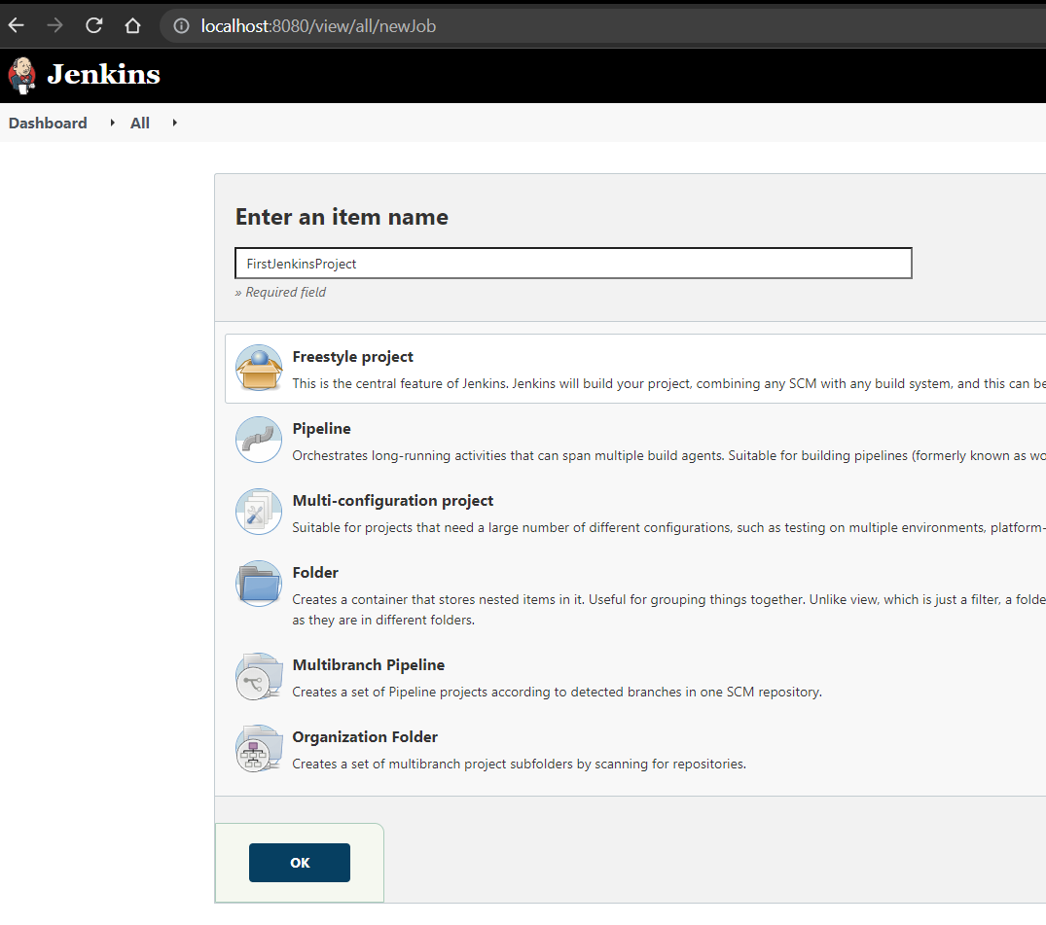

Provide some description for this project.

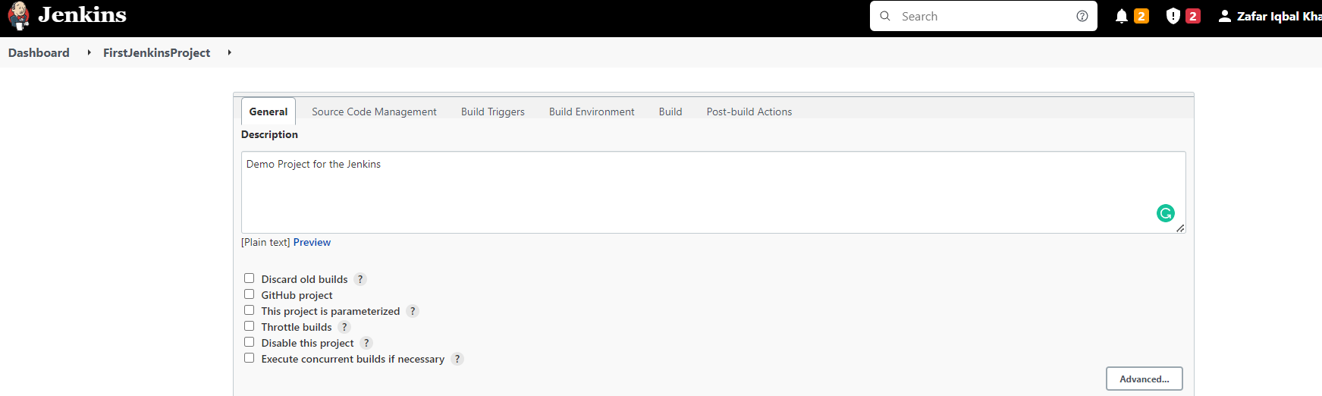

And **Execute Windows batch command,** in the build section and save

Onced saved, Dashboard will look like this

Now, click on **Build Now**, to check the output

All the builds are listed

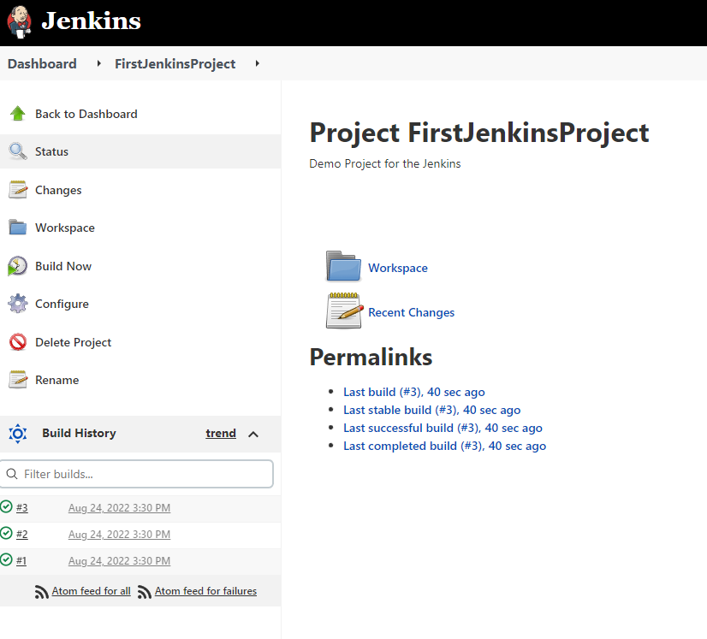

Click on any build to check for console output

As evident from the below screen, we have successfully ran our first Jenkins build job.

